DQA on Tomo

# Purpose

This procedure details the steps involved in preparing and delivering a delivery quality assurance (DQA) plan on Tomo.

For DQA troubleshooting tips, see [DQA Troubleshooting](DQA%20Troubleshooting.docx) in T:\Physics\QA & Procedures\DQA.

# Steps

1. Prep the DQA plan.
   1. On one of the Tomo computers, open the plan in DQA Station.
      1. Click the Patient Selector.
      2. Locate the patient in the list, and click the arrow next to the patient’s name.
      3. Highlight the desired plan. Ensure that its status is *Approved*. If it is not approved, you will not be able to create a DQA plan.

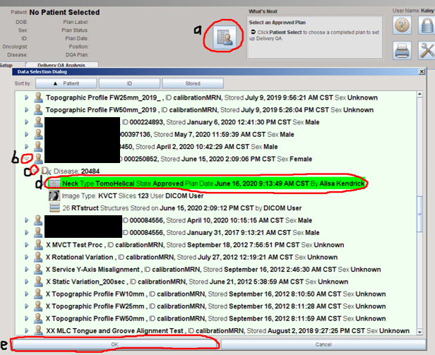

* 1. Select the Delta4 phantom.
     1. Click the **Phantom Selector** icon.

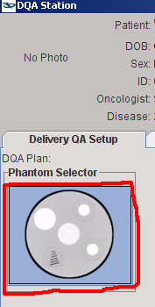

* + 1. Highlight the Delta4_2mm phantom and click *Select*.

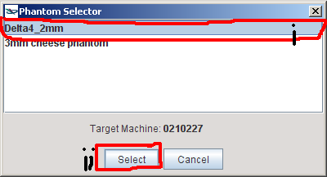

* + 1. Highlight the Delta4 phantom and click *Select*.

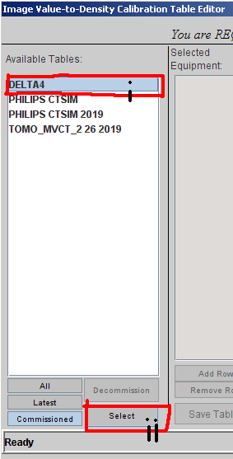

* + 1. Click *Apply to Plan*.

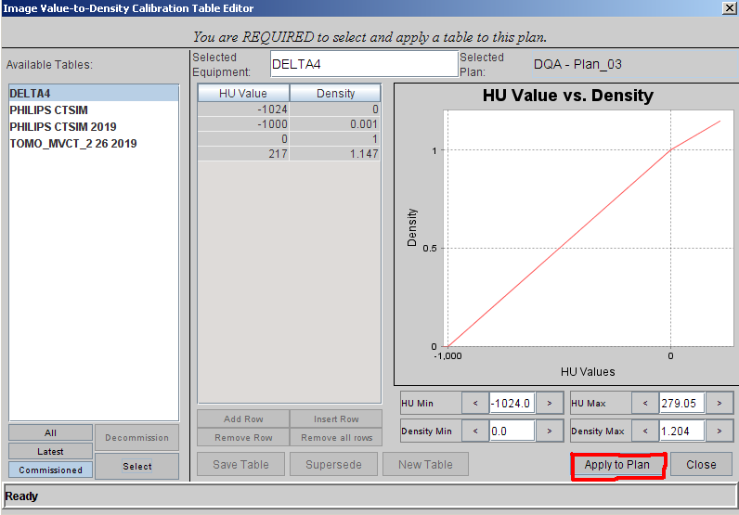

* + 1. Click *Close*.

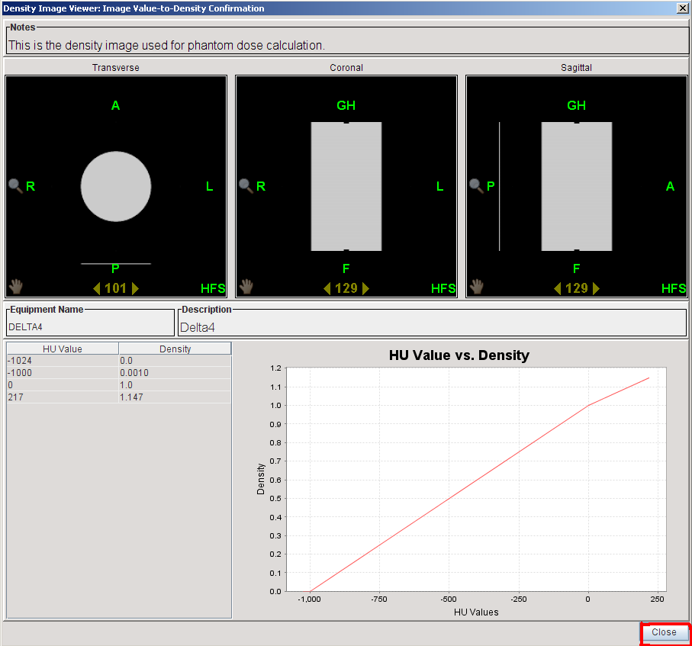

* 1. Rename the DQA plan from *Plan_01* to *<plan name> DQA*. If this name will not fit, remove letters from the end of the plan name until it does.

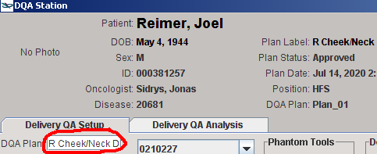

* 1. Specify view settings.
     1. Switch the Displayed Image to *Phantom*.

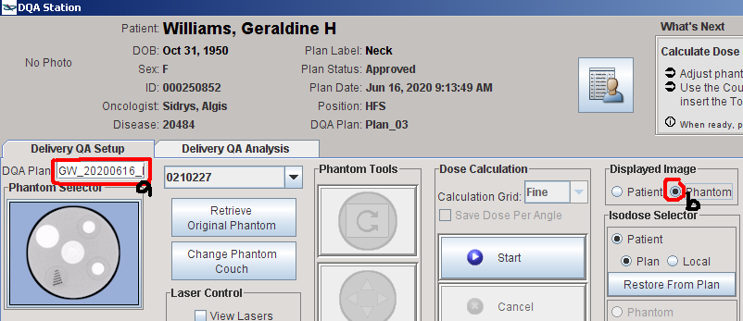

* + 1. Turn off display of all structure contours.

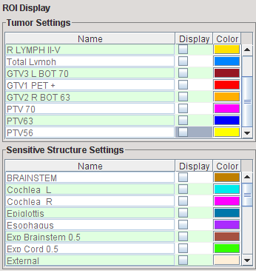

* + 1. Right-click in the scrollbar (at the right of the image) on any of the images and select *Low Density*. Move the red line down inside the scrollbar until you can see BBs on at least one of images (likely the sagittal).
    2. In each plane, scroll until you can see BBs. The BBs will likely be visible on multiple slices in each view. Try to get as much hot area (usually red and black isodose lines) on the phantom as possible, such that the BBs are still visible.

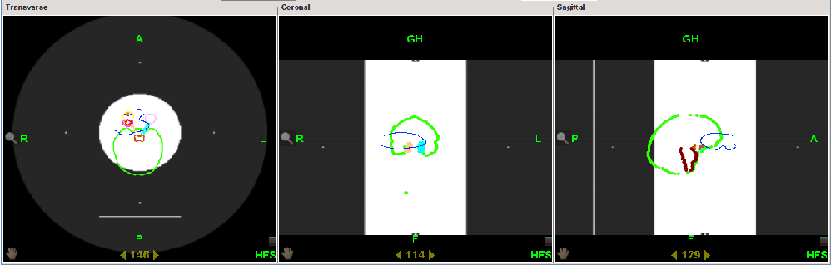

* 1. If tumor is not approximately centered on phantom, move phantom.
     1. Click *Move Phantom*.

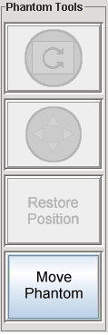

* + 1. Click the arrows button (*Move Phantom Position*).

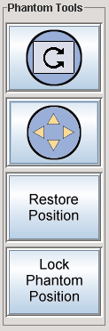

* + 1. Click and drag to move phantom in each view so that BBs align with tumor. You may need to re-scroll to see BBs and get as much hot area as possible.

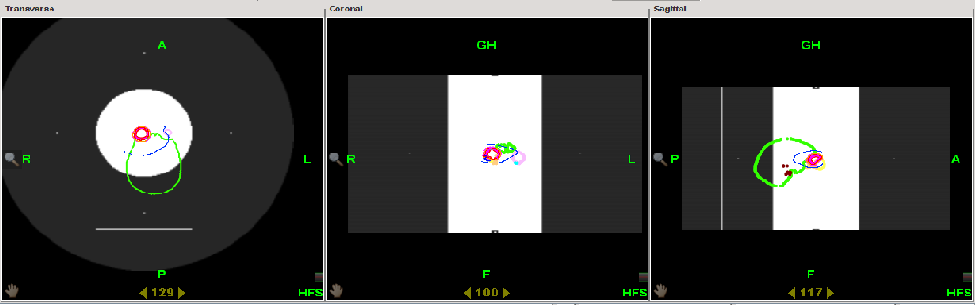

* + 1. Click *Lock Phantom Position*.

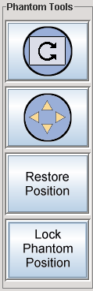

* 1. OPTIONAL: Set TCS views.
     1. Right-click in any of the views and check *Gang TCS Views*.

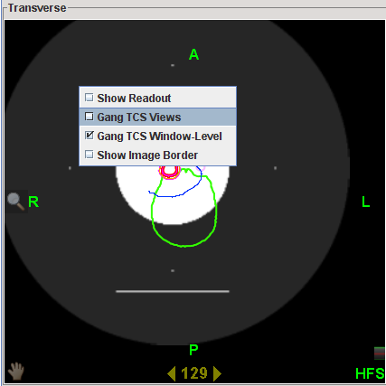

* + 1. Scroll in each plane to best align the view lasers (magenta, cyan, and yellow) to the BBs. I usually scroll in the coronal and sagittal planes to adjust the magenta and yellow lines, respectively, in the transverse view. The cyan line in the coronal view is usually already correctly positioned.
  1. Align lasers to BBs.
     1. Check *Move Lasers*. (You don’t have to check *View Lasers* first: it is automatically checked when *Move Lasers* is checked.)

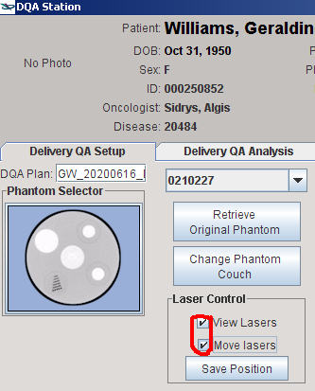

* + 1. Zoom in all the way and align each red laser to the BBs. I usually align two of the lasers in the transverse view, and the other laser in the coronal view. You will also need to use the pan tool. Zoom back out.
    2. Save the position of the red lasers.

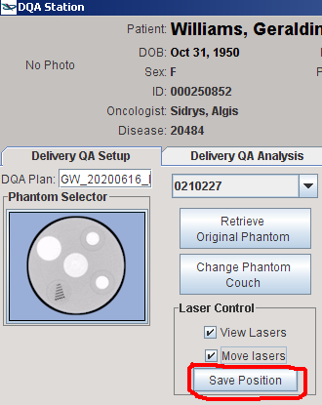

* 1. Add the couch.
     1. Click *Change Phantom Couch*.

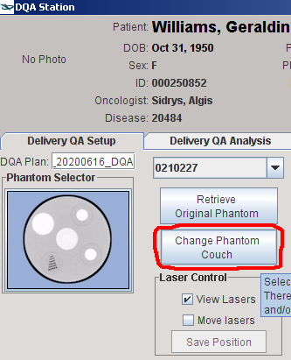

* + 1. Zoom all the way in on the gray horizontal line below the phantom. Click the vertical center, which should be bright white. A red line will appear. Click *Insert Couch*.

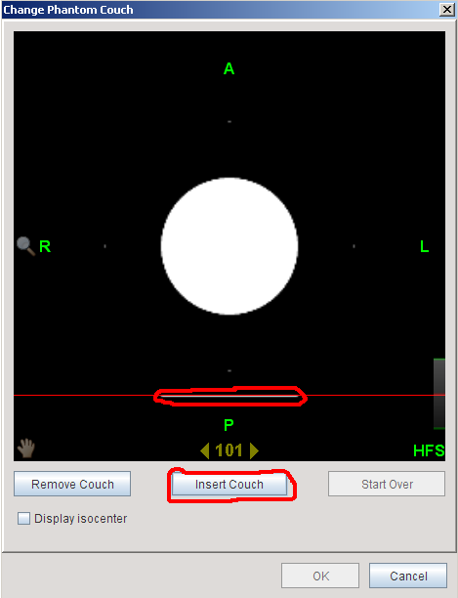

* + 1. Click *OK*.

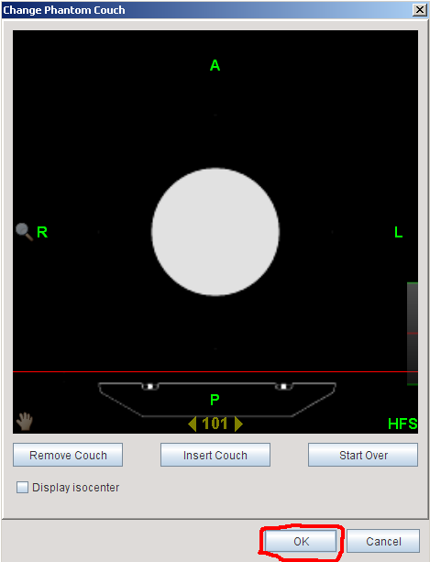

* 1. Compute the dose by clicking *Start*.

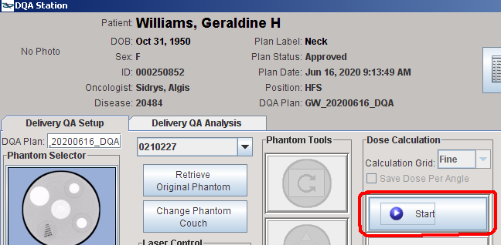

You will see the following while the job is running.

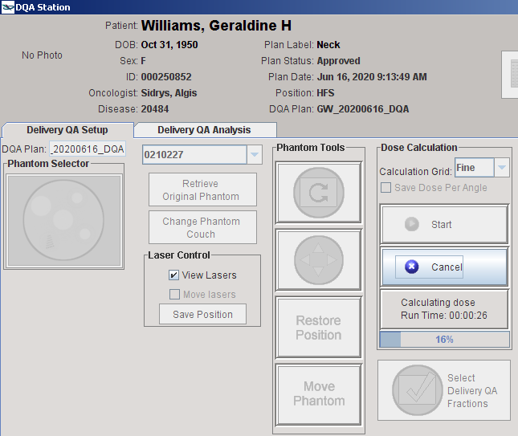

* 1. When dose computation finishes, select fractions to export.
     1. Click *Select Delivery QA Fractions*.

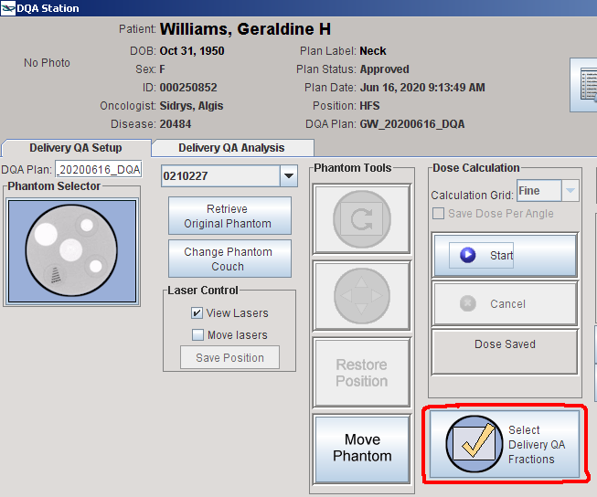

* + 1. Check the first four boxes. This gives you four fractions just in case a mistake is made or DQA needs to be shot with multiple setups.

Note the number of fractions. In the below photo, it is 39.

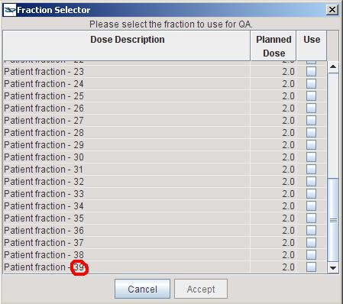

* + 1. Click *Accept*.

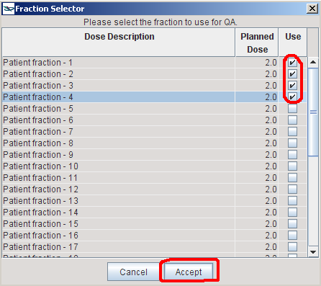

* + 1. Click *Proceed*.

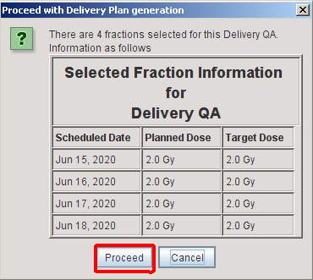

* + 1. Click *OK*.

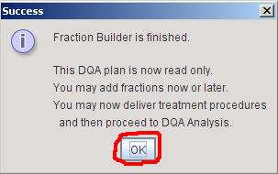

1. Ensure that the electronics in the Delta4 phantom will not be damaged. Zach’s rule of thumb is that the electronics can withstand 20 cGy per fraction.
   1. Right-click in the coronal view. Select *Show readout*.

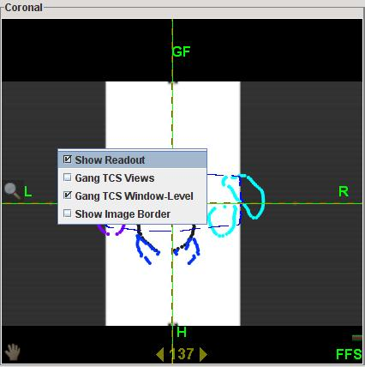

* 1. Under Isodose Selector, select the *Phantom* radio button.

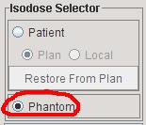

* 1. Click anywhere on the Dose Display.

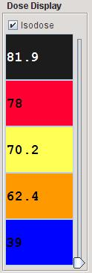

* 1. Set an isodose line for 20 cGy fractional dose. The Dose Display displays total dose, not fractional dose, so we must convert 20 cGy/fx to total dose. Multiply 20 cGy by the number of fractions noted in a previous step. This gives the total dose in cGy. Convert this to Gy by multiplying by 100. Either enter the Gy total dose in the first dose box (orange in the below screenshot) or convert to a percentage of total dose (Reference Value) and enter the percentage in the first percentage box (purple in the below screenshot).

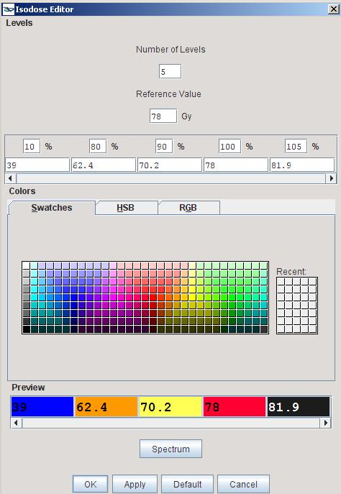

Enter dose here or dose percentage here. (Screenshot is after entering the correct percentage.)

**Example:** There are 39 fractions. 20 cGy × 39 = 780 cGy = 7.8 Gy. I could enter 7.8 in the orange box above, or convert to a percentage to enter into the purple box above: 7.8 Gy / 78 Gy × 100 = 10. The screenshot shows the percentage. When you click **OK**, the dose amount is automatically filled in. If you filled in the dose instead, the percentage would be automatically filled in.

Alternatively, if you wanted to keep the default lowest isodose line, you could add a line by incrementing the number of levels.

Click *OK* twice.

* 1. Place the cursor at the inferior edge of the 20 cGy line in the coronal view.

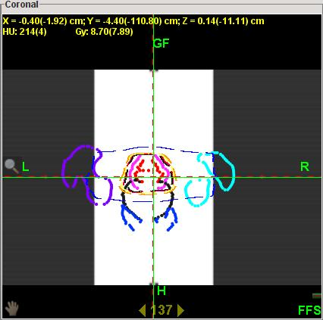

Note the Y readout. In the above photo, it is 4.4 cm. Ensure that this number is less than ~24. (The distance from the center of the Delta4 phantom to the electronics line ~22.5. On Tomo, the 22.5 line is a couple cm below the inferior edge of the phantom that is displayed in the coronal view.)

1. Export the DQA plan from Tomo. DQA Station can only send DICOM files to DICOM receivers, so we must make the Tomo PC act as a DICOM receiver. The DICOMpiler software does this. It is intended for exporting anonymized DICOM files to submit to clinical research studies, but it serves our purposes.
   1. Clear the patient from DQA Station. Just as a patient cannot be open in two different Tomo softwares at once (opening the patient locks them), you cannot export a patient’s DICOM while that patient is open.

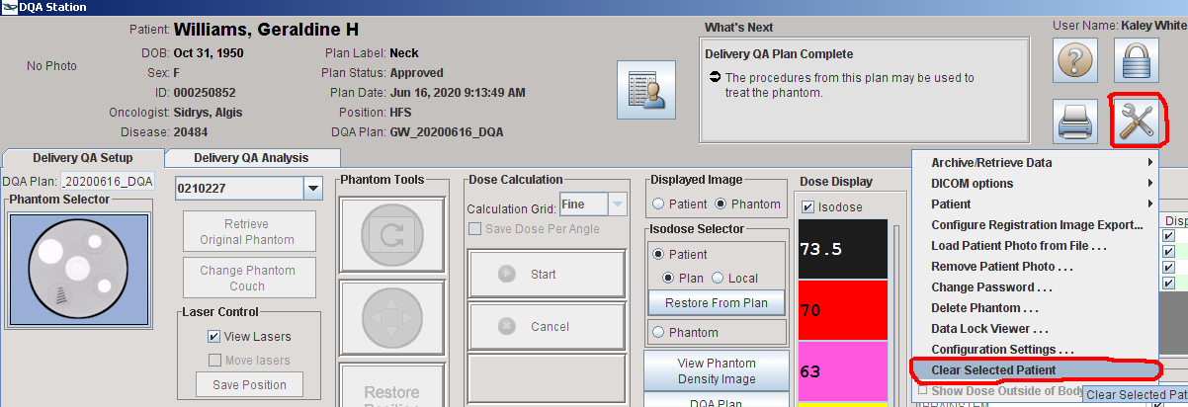

* 1. Minimize DQA Station so you can see the Delta folder on the Desktop. Open the Delta4 folder.
  2. Double click to run the DICOMpiler.

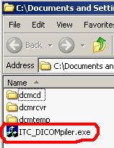

* 1. Click *OK*.

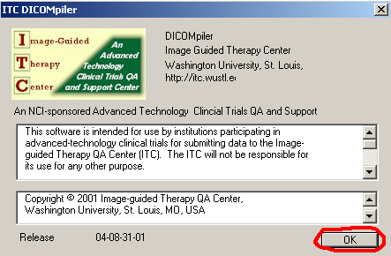

* 1. Enter the following values:
     1. Sponsor: Patient last name
     2. Protocol: Patient first name
     3. Case: Patient MRN without the three leading zeroes. (The Case field has length limit of six.)
     4. Initials: Your initials

Click *Make Patient ID*.

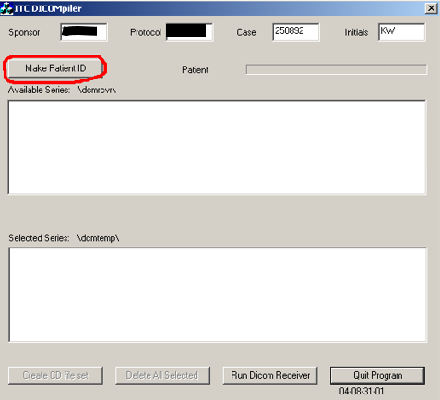

* 1. Click *Run DICOM Receiver*. The *ITC DICOM Receiver* dialog box will appear. The Tomo PC is now listening for DICOM files.

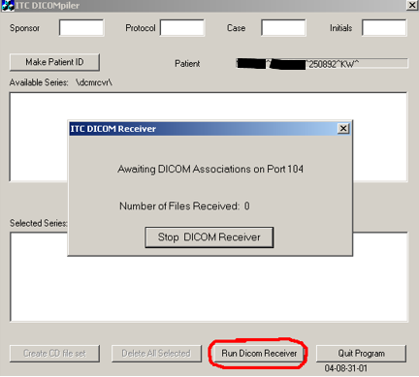

* 1. In DQA Station, go to *Toolbox* > *DICOM options* > *Export items…*

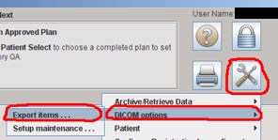

* 1. Navigate to the new DQA plan and click the arrow beside it. Ctrl+click to select the DQA plan and the Delivery_QA_Dose. We only need to export the plan and the dose, not the image or structures, because that is all we are comparing in a DQA test.

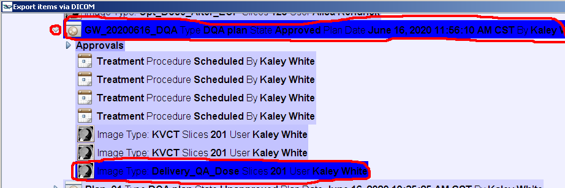

* 1. If you are on Tomo computer #1, select *Delta4_Local* from the *<Select a destination>* dropdown. If you are on Tomo computer #2, select *Delta4_PS2 Local*.

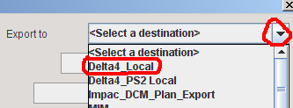

* 1. Click *Send Now*. You can try *Test Connectivity* for troubleshooting, but we rarely have issues sending DICOM from DQA Station to the Tomo PCs.

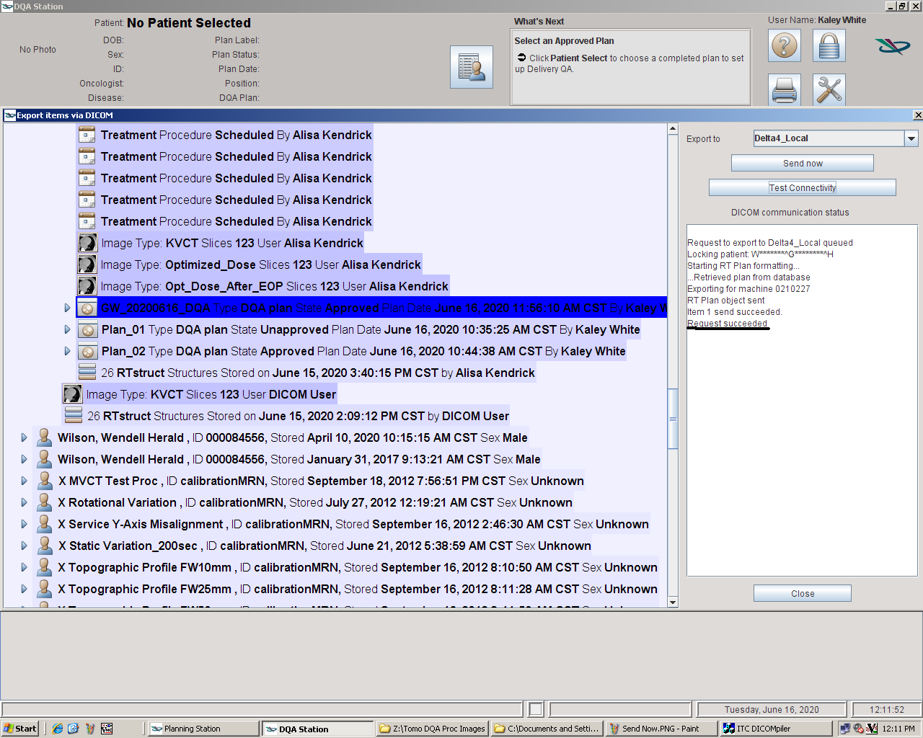

* 1. If both the DQA plan and the delivery dose were exported successfully, you will see *Request Succeeded*.

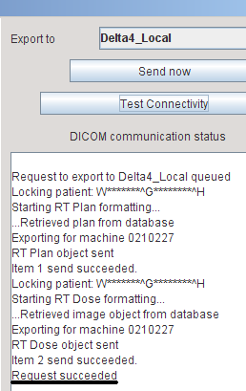

* 1. The DICOM receiver should have received two files. Stop the DICOM receiver.

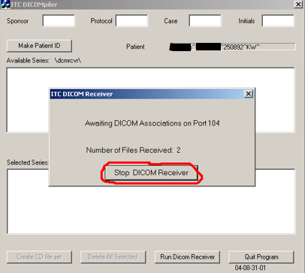

* 1. Move all files to the *dcmtemp* folder by clicking *Select All Series*.

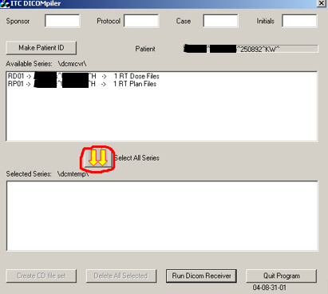

* 1. Move the files from dcmtemp to the T: drive. We must whitelist all network connections in the Tomo firewall, and the T: drive is not currently whitelisted, so we use the Z: drive, which is whitelisted, as an intermediary. The Delta4 software imports from the T: drive much faster than the Z: drive.
     1. Create a new folder in **Z:\TreatmentPlans** with the same name as the DQA plan (i.e., *<last name>, <first name> <plan name> DQA*).



* + 1. Copy or cut all files from dcmtemp to the new folder on the Z: drive called *<last name>, <first name> <plan name> DQA*. The *RP…* file is the RTPLAN, the *RD…* the RTDOSE.

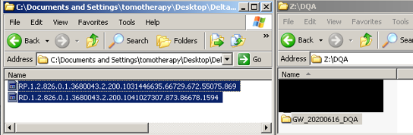

* 1. Delete all files from dcmtemp and close the DICOMpiler.

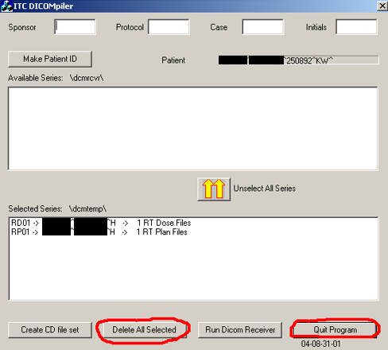

1. On another computer, move the new folder from the Z: drive to **T:\Physics\QA & Procedures\Delta4\DQA Plans**.
2. Set up the Delta4 computer.
   1. Close the Delta4 software if it open. Often, the phantom cannot connect to the software if the software is open before the phantom is turned on.
   2. Ensure that Tomo is free at the time that you want to shoot QA. You can check RO Treatment in MOSAIQ.
   3. Unplug all cables (e.g., network, power, scanner) from the Delta4 computer. Do not unplug the USB-to-network adapter. Take the Delta4 computer to the Tomo console. Plug in the network cable from behind the printer and the phantom cable from behind the computer in the corner.
3. Open the DQA plan on the Tomo computer.
   1. If THERAPIST is logged in, log out. Only Physicist users have the rights to deliver DQA plans.

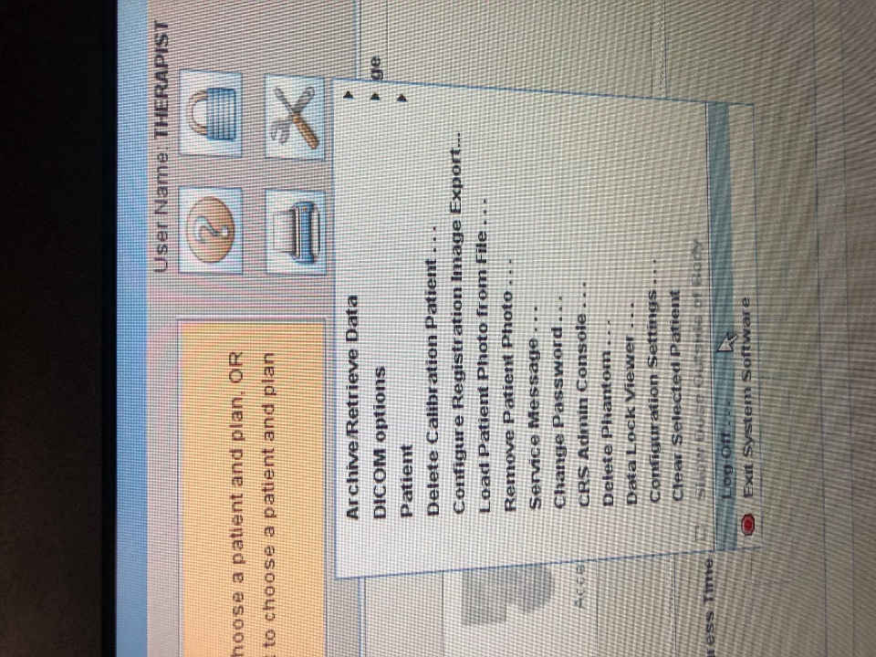

* 1. Log in using your username and password.

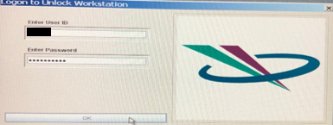

* 1. Click the Patient Selector. Navigate to and highlight the DQA plan you created earlier. Click *OK*.

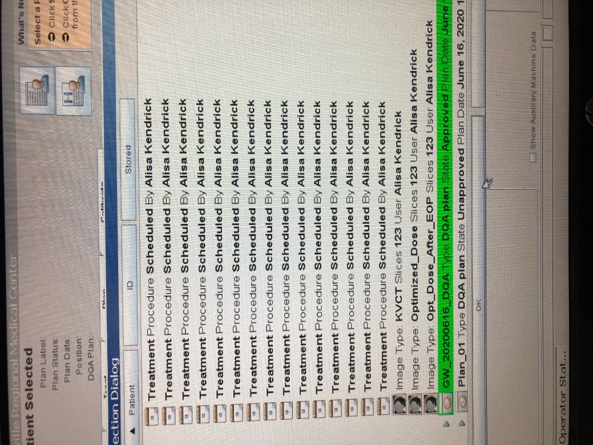

* 1. Click *Yes*.

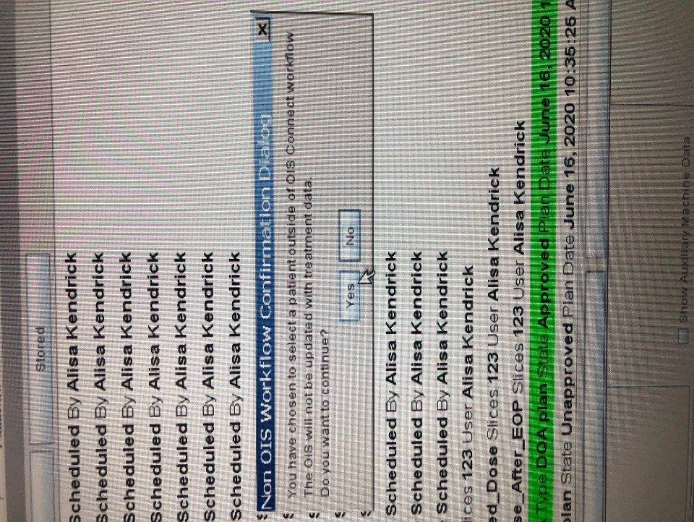

* 1. Click *Continue*.

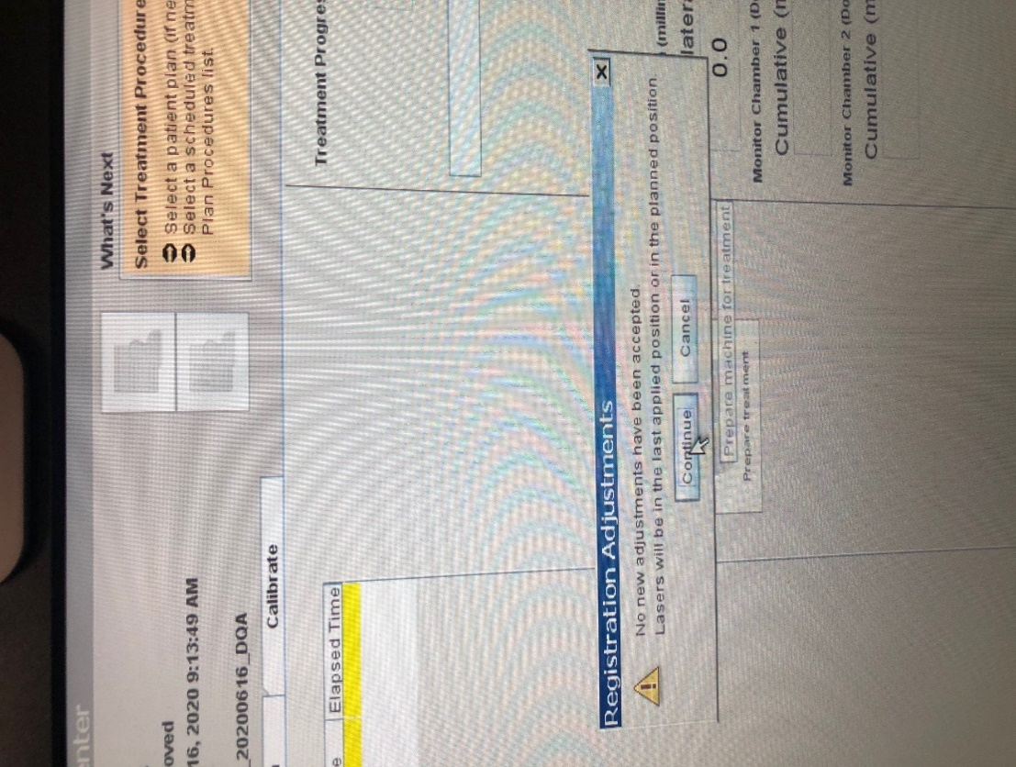

* 1. Click *OK*.

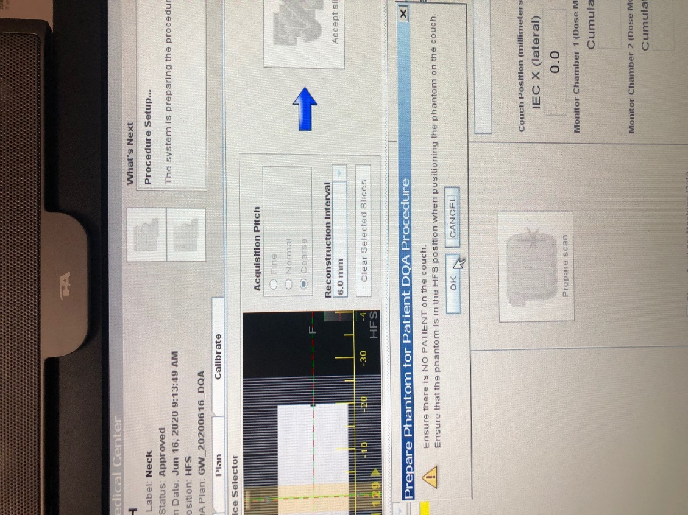

1. Prepare to shoot DQA.
   1. Navigate to the *Treat* tab, select one of the DQA-TRMT fractions, and click *Prepare treatment*.

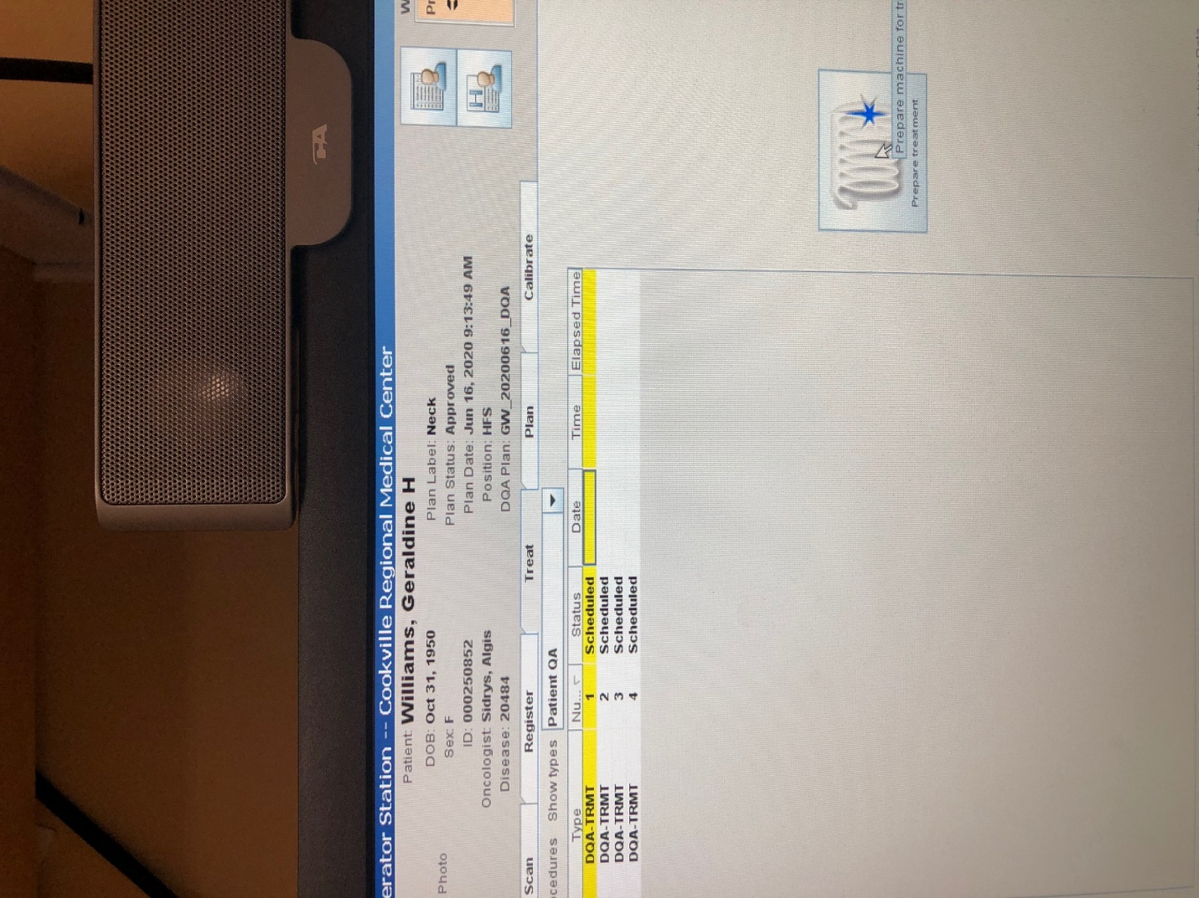

* 1. Click *Yes*.



1. Set up the Delta4 phantom.
   1. Get the Delta4 phantom cart from the hot lab. The hot lab key is in the keys bag in the cabinet to the top right of the physics assistant workstation. Unplug the phantom and put the charger in the emesis basin on the phantom cart. Get the yellow thermometer from the hot lab (OPTIONAL). Push the cart into the Tomo treatment room.
   2. If the therapists have anything on the table, scoot it to the end of the table.
   3. Push the phantom cart toward the table, and use the controls to raise the table so that the lip of the cart just overlaps the table. While holding down the large button on the bottom of the controls, push the Z switch up.
   4. Gently push the phantom onto the table, exerting some vertical force.
   5. Plug the phantom into a wall outlet if it doesn’t have enough power to run DQA. You may need the extension cord that is in the emesis bin on the cart.
   6. Turn on the phantom. The Wi-Fi light should blink blue.

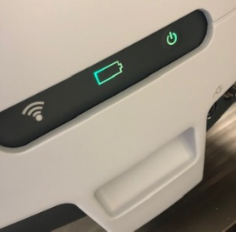

* 1. Align the phantom with the lasers.

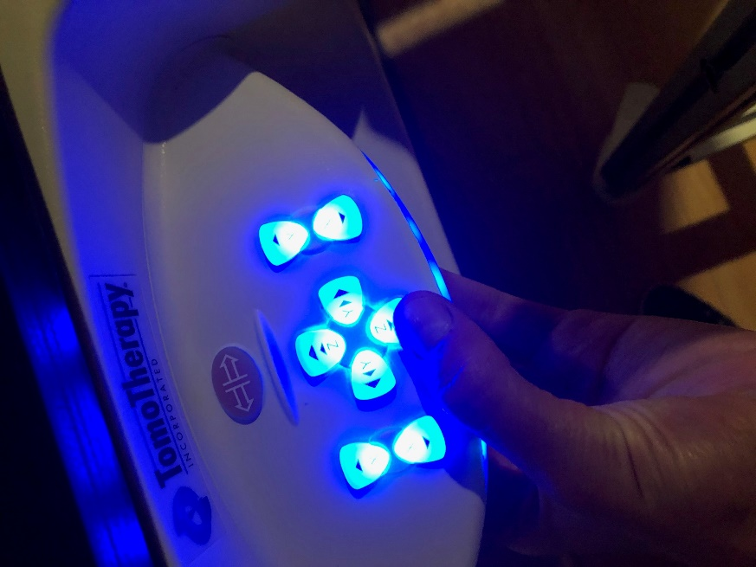

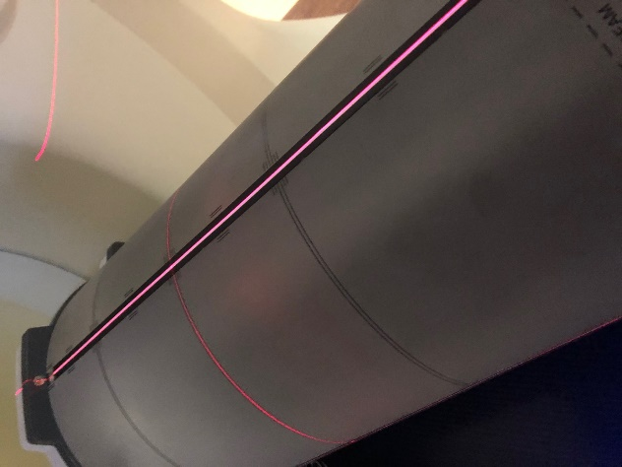

1. OPTIONAL: Use the yellow thermometer on the phantom cart to take the temperature on top of the phantom. Wait a couple of minutes for the temperature to stabilize.
2. Close the door to the treatment room. Unlike some machines, Tomo does not require you to lock the couch.
3. Click *Ready*.

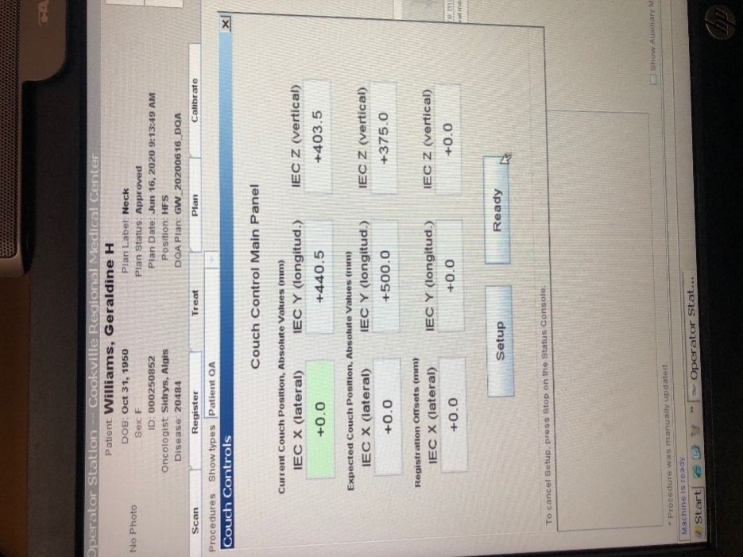

1. Click *Yes*.

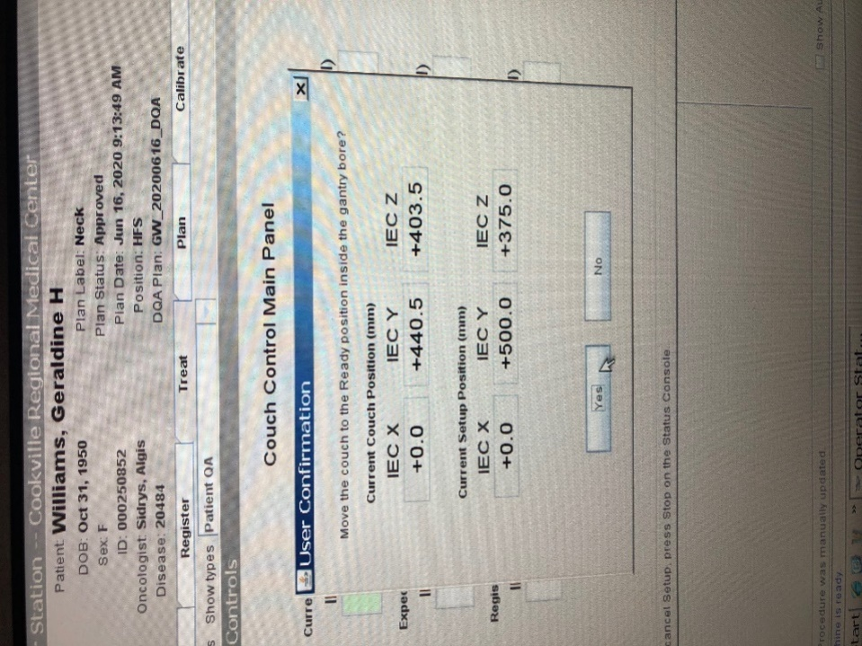

Wait until the following message appears:

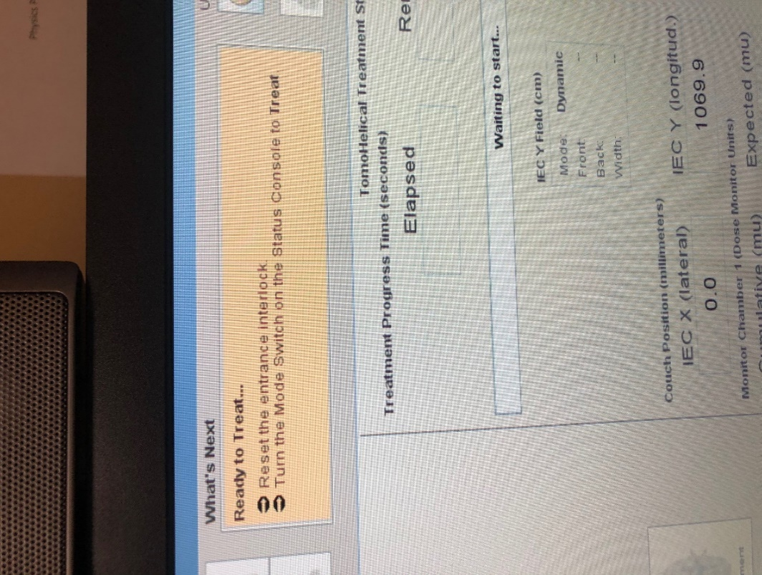

1. Shoot the field. See section “Collecting Dose” in procedure [Delta4 for DQA](Delta4%20for%20DQA.docx) in T:\Physics\QA & Procedures\DQA. Some Tomo-specific instructions:
   1. When Delta4 says “Waiting for radiation…,” turn the key on the Tomo console to *Treat*. When the *Ready* light turns green, press the green *Start* button.

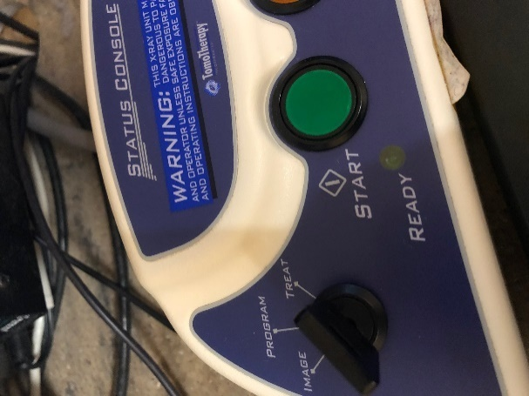

It will take a few seconds for the beam to come on. When it does, you will hear a beep.

* 1. When the progress bar finishes, turn the key on the Tomo console to *Program*.

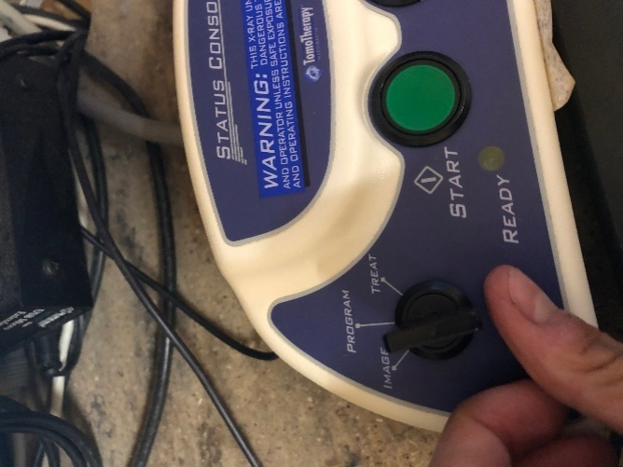

1. If you need to shoot another plan, clear the selected patient and unload the couch before loading the new plan on the Tomo computer.
2. Turn off the phantom. Unplug and unload from the table. Restore the table setup to the way it was before you shot QA. Unload the couch.
3. Log out of the Tomo software. Log back in as a therapist using username *therapist* and password *therapist1*.
4. Optionally, leave a Post-It note on the monitor saying what time you finished running beam. After any extended period (such as lunch) without beam, the therapists must warm up the machine, so it’s nice to let them know if this is not necessary. Example Post-It text:

Finished running beam @ 12:35

* KW

1. Return the phantom to the hot lab. When you plug the phantom in, the battery light should be orange. Replace the thermometer on the bookshelf.

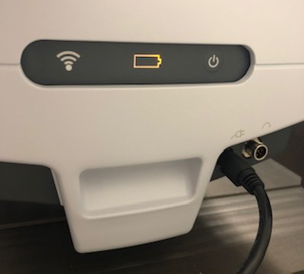

1. Carry the Delta4 computer back to Physics and plug back in the cables.
2. Evaluate the beam statistics. See section “Analyzing Dose” in procedure Delta4 for DQA in T:\Physics\QA & Procedures\DQA.
3. Print the Physics Report. See section “Printing a Report” in procedure Delta4 for DQA in T:\Physics\QA & Procedures\DQA.
4. Upload the Physics Report to MOSAIQ. See procedure [Upload DQA Physics Report to MOSAIQ](Upload%20DQA%20Physics%20Report%20to%20MOSAIQ.docx) in T:\Physics\QA & Procedures\DQA.